

**SQL QUERIES:**

create database form

use form

create table info

(

book_id int primary key identity(1,1),

book_name varchar(50) not null,

aurthor nvarchar(50) not null,

price bigint not null

)

drop table info

select * from info

**SQL OUTPUT:**

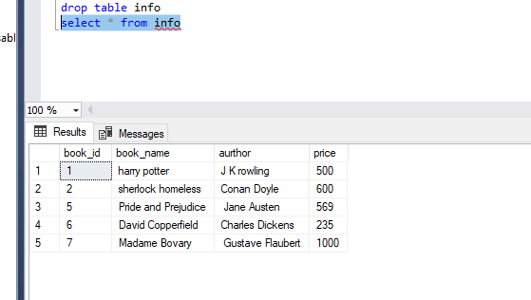

**VISUAL STUDIO:**

**CLASS CODE:**

using System;

using System.Collections.Generic;

using System.Linq;

using System.Text;

using System.Threading.Tasks;

using System.Data;

using System.Data.SqlClient;

namespace WindowsFormsApp1

{

class databaseOperation

{

SqlConnection con;

public databaseOperation(string conString)

{

this.con = new SqlConnection(conString);

}

public DataTable GetData(string query )

{

SqlCommand cmd = new SqlCommand(query, con);

SqlDataAdapter adapter = new SqlDataAdapter(cmd);

DataTable dt = new DataTable();

con.Open();

adapter.Fill(dt);

con.Close();

return dt;

}

public void printData(string query)

{

DataTable dt = new DataTable(query);

for (int i = 0; i < dt.Rows.Count; i++)

{

for (int j = 0; j < dt.Columns.Count; j++)

{

Console.WriteLine(dt.Rows[i][j].ToString()+"\t");

}

}

}

public void insertTo(string query)

{

con.Open();

SqlCommand cmd = new SqlCommand(query,con);

cmd.CommandText = query;

cmd.ExecuteNonQuery();

con.Close();

}

public void UpdateData(string query)

{

con.Open();

SqlCommand cmd = new SqlCommand(query, con);

cmd.ExecuteNonQuery();

cmd.CommandText = query;

con.Close();

}

public void delete(string query)

{

con.Open();

SqlCommand cmd = new SqlCommand(query, con);

cmd.ExecuteNonQuery();

cmd.CommandText = query;

con.Close();

}

}

}

**FORM CODE:**

using System;

using System.Collections.Generic;

using System.ComponentModel;

using System.Data;

using System.Drawing;

using System.Linq;

using System.Text;

using System.Threading.Tasks;

using System.Windows.Forms;

using System.Data.SqlClient;

namespace WindowsFormsApp1

{

public partial class Form1 : Form

{

public Form1()

{

InitializeComponent();

}

public int myid;

int id = 0;

databaseOperation dbop = new databaseOperation("Data Source=DESKTOP-BBK81VC;Initial Catalog=form;Integrated Security=True");

private void button1_Click(object sender, EventArgs e)

{

dbop.insertTo("insert into info values ('" +textBox1.Text+ "','" + textBox2.Text + "','" + textBox3.Text + "')");

MessageBox.Show("Record inserted successfully", "Congrass", MessageBoxButtons.OK);

clear();

dataGridView1.DataSource = dbop.GetData("select * from info");

}

private void button4_Click(object sender, EventArgs e)

{

dataGridView1.DataSource = dbop.GetData("select * from info");

}

public void clear()

{

textBox1.Clear();

textBox2.Clear();

textBox3.Clear();

}

private void button2_Click(object sender, EventArgs e)

{

if (myid > 0)

{

dbop.UpdateData(@"Update info set book_name='" + textBox1.Text + "',aurthor='" + textBox2.Text + "',price='" + textBox3.Text + "'where book_id = '" + myid + "'");

dataGridView1.DataSource = dbop.GetData("select * from info");

MessageBox.Show("Record updated successfully", "Congrass", MessageBoxButtons.OK);

clear();

}

else

{

MessageBox.Show("Please Select A record to update", "Error", MessageBoxButtons.OK);

}

}

private void button3_Click(object sender, EventArgs e)

{

if (myid> 0)

{

dbop.delete(@"delete from info where book_id = '" + myid+ "'");

dataGridView1.DataSource = dbop.GetData("select * from info");

MessageBox.Show("Record delete successfully", "Congrass", MessageBoxButtons.OK);

clear();

}

else

{

MessageBox.Show("Please Select A record to update", "Error", MessageBoxButtons.OK);

}

}

private void dataGridView1_CellContentClick(object sender, DataGridViewCellEventArgs e)

{

}

private void dataGridView1_RowHeaderMouseClick(object sender, DataGridViewCellMouseEventArgs e)

{

myid = int.Parse(dataGridView1.SelectedRows[0].Cells["book_id"].Value.ToString());

textBox1.Text = dataGridView1.SelectedRows[0].Cells["book_name"].Value.ToString();

textBox2.Text = dataGridView1.SelectedRows[0].Cells["aurthor"].Value.ToString();

textBox3.Text = dataGridView1.SelectedRows[0].Cells["price"].Value.ToString();

}

}

}

**OUTPUT:**

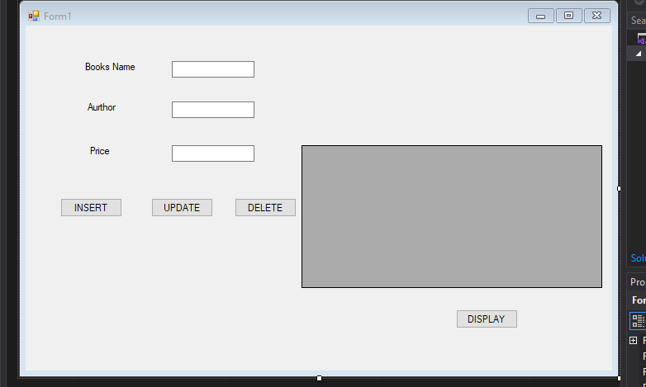

**RESULTS:**

**INSERT:**

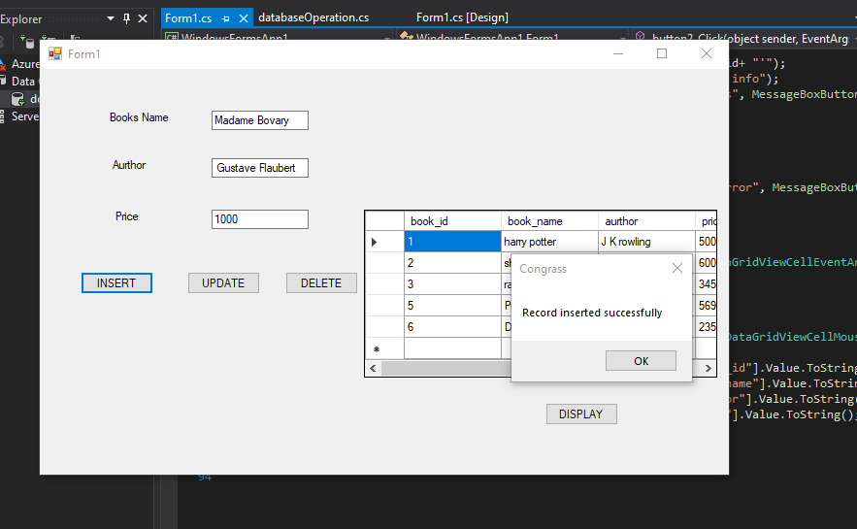

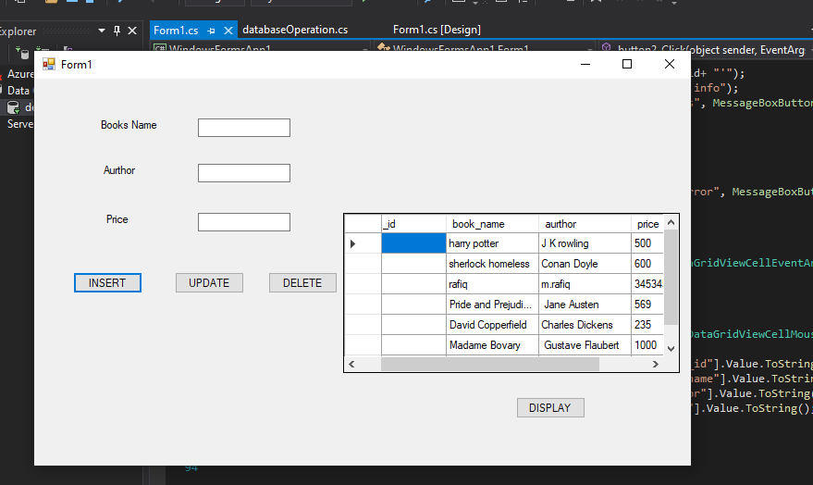

**UPDATE:**

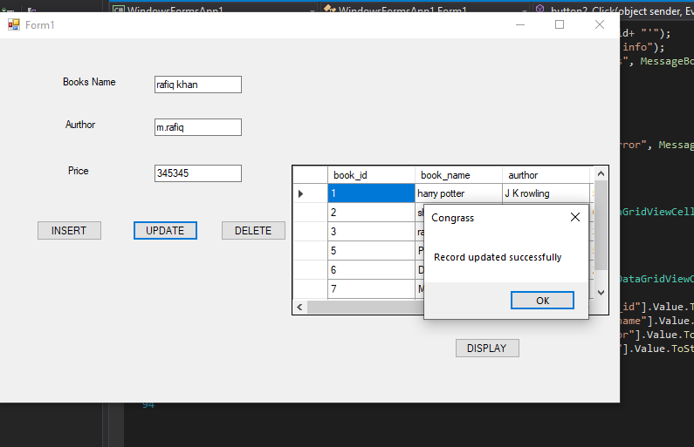

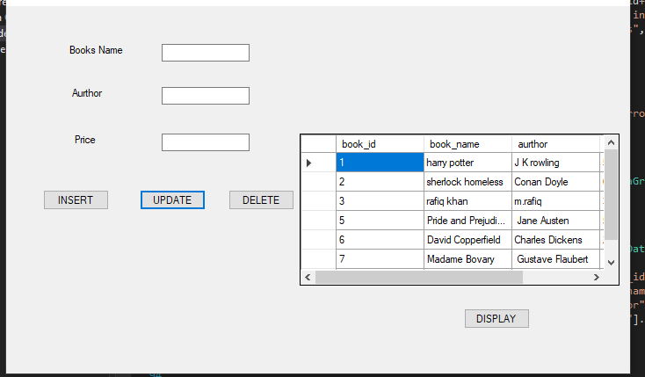

**DELETE:**

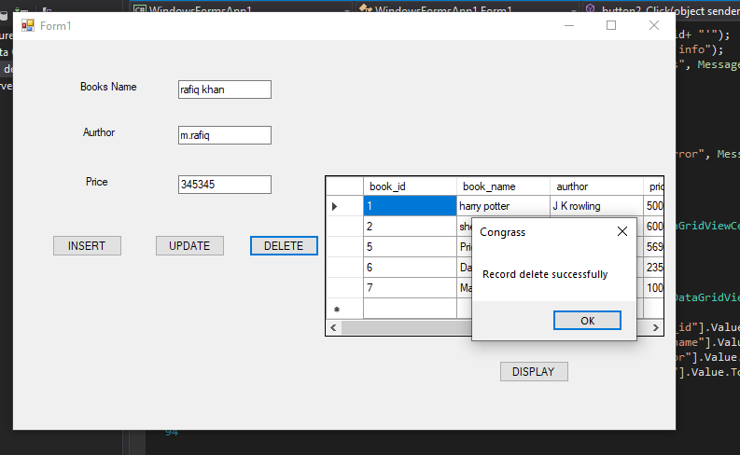

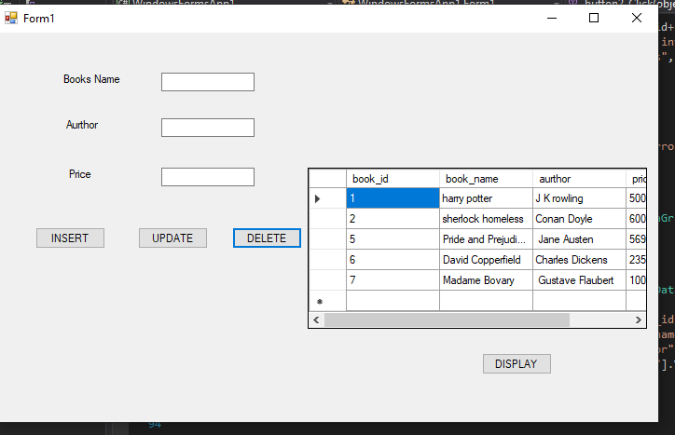

**DISPLAY:**

